CPA2B Marketing Templates
Student Save the Date (ASAP):
Email Header:
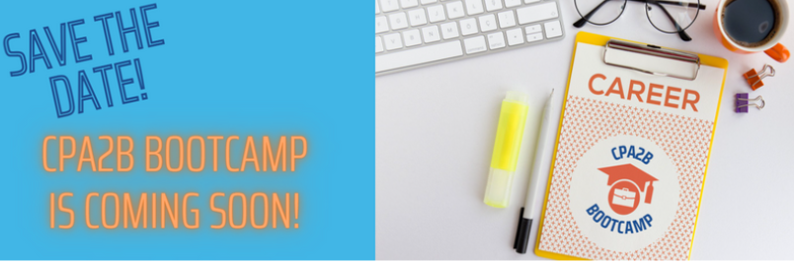
Subject: Save the Date: You're Invited to [Insert Chapter Name's] CPA2B Bootcamp
Copy: Join us virtually [insert date] to learn more about your future career, taking your resume to the next level and harnessing the power of certification! Hear from CPAs who have been where you are now and learn tips on how to excel in the field. Attendees will experience:
- An open Q&A session with a panel of CPAs
- A hands-on workshop to level up your resume game
- Networking tips and tricks to wow future employers and clients
- An update on what your path to CPA will look like
Mark your calendar now! More information on how you can join your peers and fellow [chapter name] members for the CPA2B Bootcamp will be sent soon!

Social Post:
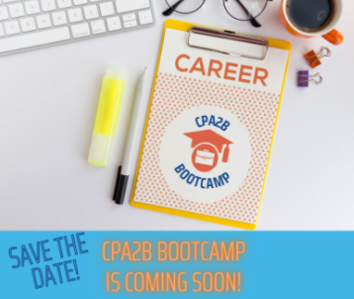
Save the Date: You're Invited to [Insert Chapter Name's] CPA2B Bootcamp on [insert date]. Stay tuned for information on how to jumpstart your future career success!
Educator/University Contacts Save the Date (ASAP):
Email Header:
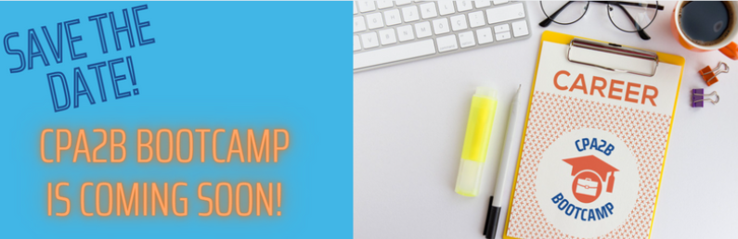
Subject: Save the Date: Your Students are Invited to [Insert Chapter Name's] CPA2B Bootcamp
Copy: Have your students join us virtually [insert date] to learn more about their future career, taking their resume to the next level and harnessing the power of certification! They will hear from CPAs who have been in their shoes and learn tips on how to excel in the field. Attendees will experience:
- An open Q&A session with a panel of CPAs
- A hands-on workshop to level up your resume game
- Networking tips and tricks to wow future employers and clients
- An update on what your path to CPA will look like
Mark your calendar now! More information on how your students can be a part of the CPA2B Bootcamp will be sent soon! In the meantime, feel free to spread the word and send along this attached flyer [flyer can be accessed via the google drive] with more information.
Student Announcement (6-8 weeks prior to the event):
Email Header:
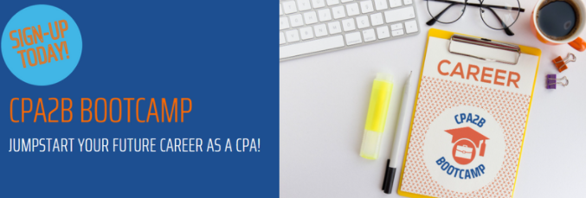
Subject: Jumpstart Your Career: Sign-up Today for [Insert Chapter Name's] CPA2B Bootcamp
Copy: Join us virtually [insert date] to learn more about your future career, taking your resume to the next level and harnessing the power of certification! Hear from CPAs who have been where you are now and learn tips on how to excel in the field. Attendees will experience:
- An open Q&A session with a panel of CPAs
- A hands-on workshop to level up your resume game
- Networking tips and tricks to wow future employers and clients
- An update on what your path to CPA will look like
Sign-up today and join your peers and fellow [chapter name] members for this one-of-a-kind experience.

Social Post:
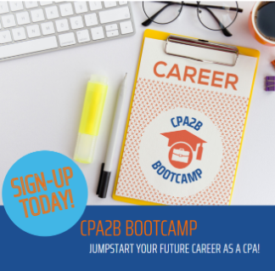
Jumpstart your career as a future CPA by being a part of [Insert Chapter Name's] virtual CPA2B Bootcamp on [insert date]. Don't miss this one of a kind event!
Educator/University Contact Announcement (6-8 weeks prior to the event):
Email Header:
Subject: Jumpstart Their Careers: Students Can Sign-up Today for [Insert Chapter Name's] CPA2B Bootcamp
Copy: Encourage your students to join us virtually [insert date] to learn more about their future career, taking their resume to the next level and harnessing the power of certification! Attendees will experience:
- An open Q&A session with a panel of CPAs
- A hands-on workshop to level up your resume game
- Networking tips and tricks to wow future employers and clients
- An update on what your path to CPA will look like
Students can sign-up today to join their peers and fellow [chapter name] members for this one-of-a-kind experience. Feel free to spread the word and send along this attached flyer [flyer can be accessed via the google drive] with more information.
Student Reminder (2 weeks post announcement):
Email Header:
Subject: Sign-up Today for [Insert Chapter Name's] CPA2B Bootcamp
Copy: Don't miss [Insert Chapter Name's] virtual CPA2B Bootcamp [insert date] for an opportunity to learn more about your future career, take your resume to the next level and harness the power of certification! Attendees will experience:
- An open Q&A session with a panel of CPAs
- A hands-on workshop to level up your resume game
- Networking tips and tricks to wow future employers and clients
- An update on what your path to CPA will look like
Sign-up today and join your peers and fellow [chapter name] members for this one of a kind experience.

Social Post:
Don't miss [Insert Chapter Name's] virtual CPA2B Bootcamp on [insert date] to jumpstart your career as a future CPA. Sign-up today!
Educator/University Contact Reminder (2 weeks post announcement):
Email Header:
Subject: Spread the Word: [Insert Chapter Name's] CPA2B Bootcamp is [Insert the date]
Copy: Don't miss the opportunity for your students to attend [Insert Chapter Name's] virtual CPA2B Bootcamp [insert date] to learn more about their future career, take their resume to the next level and harness the power of certification! Attendees will experience:
- An open Q&A session with a panel of CPAs
- A hands-on workshop to level up your resume game
- Networking tips and tricks to wow future employers and clients
- An update on what your path to CPA will look like
Share the registration link below and pass along the attached flyer to anyone who may be interested in jumpstarting their career with this one-of-a-kind experience.
Optional Student Reminder (6 weeks post announcement - if you have an 8-week promotion window):
Email Header:
Subject: Still Time to Jumpstart Your Career at [Insert Chapter Name's] CPA2B Bootcamp
Copy: Don't miss [Insert Chapter Name's] virtual CPA2B Bootcamp [insert date] for an opportunity to learn more about your future career, take your resume to the next level and harness the power of certification! Attendees will experience:
- An open Q&A session with a panel of CPAs
- A hands-on workshop to level up your resume game
- Networking tips and tricks to wow future employers and clients
- An update on what your path to CPA will look like
Sign-up today and join your peers and fellow [chapter name] members for this one of a kind experience.

Social Post:
Still time to sign-up for [Insert Chapter Name's] virtual CPA2B Bootcamp on [insert date] to jumpstart your career as a future CPA.
Final Call for Students (week prior to the event):
Email Header:
Subject: One Week Until [Insert Chapter Name's] CPA2B Bootcamp - Sign-up Today!
Copy: Last chance to experience [Insert Chapter Name's] virtual CPA2B Bootcamp on [insert date] to learn more about your future career, take your resume to the next level and harness the power of certification! You will experience:
- An open Q&A session with a panel of CPAs
- A hands-on workshop to level up your resume game
- Networking tips and tricks to wow future employers and clients
- An update on what your path to CPA will look like
Don't miss this one-of-a-kind experience to learn from fellow [chapter name] members and network with your peers. Sign-up today!
Social Post:
Last chance to sign-up for [Insert Chapter Name's] virtual CPA2B Bootcamp on [insert date] to jumpstart your career as a future CPA.
Final Call for Educators/University Contacts (week prior to the event):
Email Header:
Subject: One Week Until [Insert Chapter Name's] CPA2B Bootcamp!
Copy: Last chance for your students to sign-up and experience [Insert Chapter Name's] virtual CPA2B Bootcamp on [insert date]. They will experience:
- An open Q&A session with a panel of CPAs
- A hands-on workshop to level up your resume game
- Networking tips and tricks to wow future employers and clients
- An update on what your path to CPA will look like
Feel free to send along the attached flyer, maybe offer some extra credit for attending and have them register via the link below! We hope to see your university represented and appreciate your help with getting the word out about this awesome event.
What You Need to Know (2-5 days prior to the event):
Email Header:
Subject: It's Almost Time: Now Let's Get CPA2B Bootcamp Ready!
Copy: You're in! Now let's make sure you make the most of the upcoming [Insert Chapter Name's] virtual CPA2B Bootcamp [insert date]. To prepare, we put together a few reminders and tips below:
- Make sure you are camera-ready to help with engagement
- Dress for success - you may be networking with a future employer
- Upload the latest version of your resume for review in this google drive [insert link]
- Have questions? Add them here [insert link to google form] so speakers can prepare in advance
- Ask your questions by going off mute (stay on mute otherwise to avoid background noise)
We look forward to seeing you virtually real soon. If you have further questions, feel free to reach out to XX [insert chapter contact's email].
Thank you to students for attending, reintroduce student member benefits and chapter events:
From: Chapter representative's email address
Image: Snapshot of zoom attendees but not necessary to have an image for this communication
Subject: Thank you for attending [Insert Chapter Name's] CPA2B Bootcamp!
Copy: We can't thank you enough for being a part of the CPA2B Bootcamp. We hope the experience will fuel and prepare your journey to certification and career success. Please take a moment to complete this short evaluation [insert link to a google form] to help us improve the experience and program in the future.
We are excited to have you as a TXCPA student member and look forward to being your career advocate now and into the future. Be sure to make the most of your membership by taking advantage of:
- Future chapter student events [include any specific details for events here]
- Scholarships opportunities
- CPA Exam prep course discounts
- Free access to Thomson Reuters' Practice Ready Online Learning Program
- Connection with your peers and 28K Texas Society of CPA members via:
- TXCPA Exchange, exclusive members-only online forum, for questions and knowledge sharing
- Searchable online directory
- Dedicated communications and resources to keep you up-to-date on critical professional news
- Student Ambassador program to help spread the news of TXCPA membership on your campus
If you have further questions, feel free to reach out to XX [insert chapter contact's email] or Melinda Bentley at the Texas Society of CPAs.
Social Post Suggestion:
Image: Post pic of zoom window with attendees
Copy: Our virtual CPA2B Bootcamp was held XX [insert date of program] with [insert # of attendees, # of schools represented] hopeful future CPAs ready to jumpstart their career! We look forward to all they will be able to accomplish as the future of the accounting profession.
Thank you to Educators/University contacts for helping!
From: Chapter representative's email address
Image: Snapshot of zoom attendees but not necessary to have an image for this communication
Subject: Thank you for helping make the [Insert Chapter Name's] CPA2B Bootcamp a success!
Copy: We can't thank you enough for encouraging your students to attend the CPA2B Bootcamp. We hope the experience will further fuel and prepare them for their journey to certification and career success.
We are excited to have your students as TXCPA members. If some of your students were unable to attend and would like to become members, it's free! All they have to do is sign-up here and they gain access to benefits like these:
- Future chapter student events [include any specific details for events here]
- Scholarships opportunities
- CPA Exam prep course discounts
- Free access to Thomson Reuters' Practice Ready Online Learning Program
If you are not currently an educator member, we encourage you to look into becoming an Educator ambassador which comes with a special dues rate and free registration to the annual Accounting Education Conference. Find out more here!
If you have further questions, feel free to reach out to XX [insert chapter contact's email] or Melinda Bentley at the Texas Society of CPAs.
Again, thank you for all you did to help with this event and all you do for the future of the profession!

