TXCPA Evaluation Questions:
- Please rate the experience. (Poor 1 to Excellent 10)
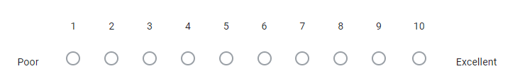
- What one or two words would describe this experience for you?
- What were the 3 most valuable things you learned?
- On a scale from 1-5, how helpful was the program to your future success in accounting?
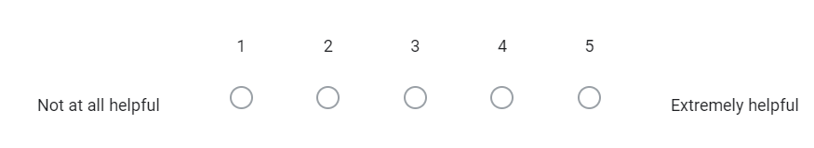
- Did the program further your interest/commitment to entering the accounting field and/or becoming a CPA?
Yes, No, Maybe, Other
- What topics were missing for you?
- What could we do to improve the program in the future?
- What could the chapter and/or TXCPA do to better prepare you for future career success?
- How likely are you to recommend this program to a friend or peer?
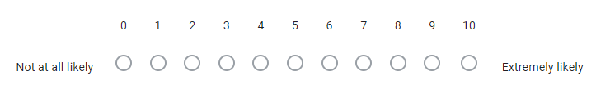
- If willing, please provide a testimonial detailing your experience to use in next year's promotions (please include your name and school with your testimonial).
- Please provide any additional feedback you may have you feel would be helpful in future planning?

